WEB DEVELOPMENT
ACTIVITY-BASED LEARNING
DIGITAL LIBRARY MANAGEMENT SYSTEM

Student Name: Thota Hima Sri
Roll Number: 26001252
College: NRI UNIVERSITY
Branch: CSM
Year: 1st Year
Subject: Web Development

1. Introduction
The Digital Library Management System is a simple website developed using HTML and CSS. It presents book categories, featured books, a book catalog, and library rules in an organized layout.

2. Objectives
- To create a user-friendly digital library webpage.
- To display book details and availability status.
- To organize books by categories.
- To practice HTML structure and CSS styling.
- To make the page responsive for smaller screens.

3. Technologies Used
HTML5: Defines the webpage structure, headings, navigation, lists, book details, table, and footer.
CSS3: Controls colors, spacing, grid layout, borders, shadows, typography, and responsive design.

4. Output of the Project
The following is an illustrative preview of the webpage based on the HTML and CSS in the GitHub repository.
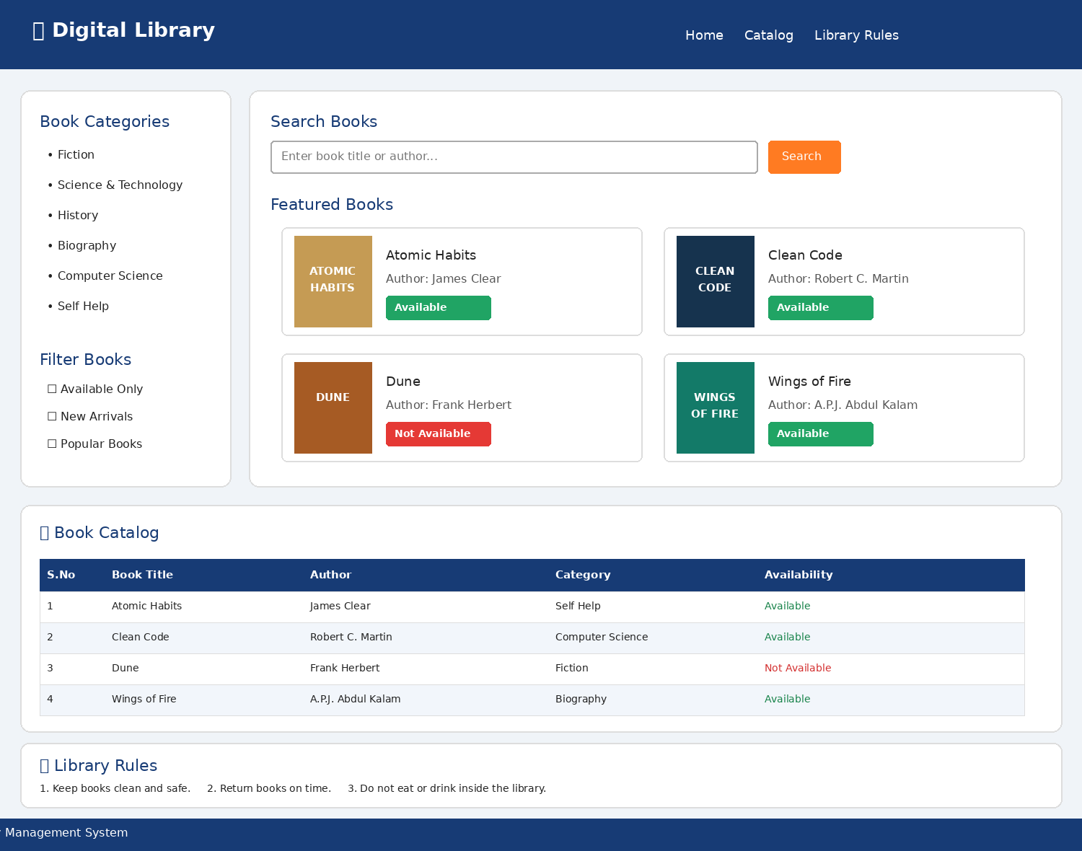
The page contains a navigation bar, book categories and filters, four featured book cards, a catalog table, library rules, and a footer.

5. How to Run the Project
- Download index.html and style.css from the GitHub repository into the same folder.
- Make sure both files are in the same folder because index.html links to style.css.
- Double-click index.html, or right-click it and open it with a web browser.
- The Digital Library webpage will appear in the browser.
GitHub repository: https://github.com/thotahimasri3-jpg/WD-Activity-Based

6. HTML Source Code (index.html)
<!DOCTYPE html>
<html lang="en">
<head>
<meta charset="UTF-8">
<meta name="viewport" content="width=device-width, initial-scale=1.0">
<title>Digital Library</title>
<link rel="stylesheet" href="style.css">
</head>
<body>
<header>
<h1>📚 Digital Library</h1>
<nav>
<a href="#home">Home</a>
<a href="#catalog">Catalog</a>
<a href="#rules">Library Rules</a>
</nav>
</header>
<div class="container" id="home">
<aside>
<h2>Book Categories</h2>
<ul>
<li>Fiction</li>
<li>Science & Technology</li>
<li>History</li>
<li>Biography</li>
<li>Computer Science</li>
<li>Self Help</li>
</ul>
<h2>Filter Books</h2>
<label><input type="checkbox"> Available Only</label><br>
<label><input type="checkbox"> New Arrivals</label><br>
<label><input type="checkbox"> Popular Books</label>
</aside>
<main>
<h2>Search Books</h2>
<input type="text" placeholder="Enter book title or author...">
<button>Search</button>
<h2>Featured Books</h2>
<div class="book-grid">
<div class="book">
<div class="cover cover1">ATOMIC<br>HABITS</div>
<h3>Atomic Habits</h3>
<p>Author: James Clear</p>
<span class="available">Available</span>
</div>
<div class="book">
<div class="cover cover2">CLEAN<br>CODE</div>
<h3>Clean Code</h3>
<p>Author: Robert C. Martin</p>
<span class="available">Available</span>
</div>
<div class="book">
<div class="cover cover3">DUNE</div>
<h3>Dune</h3>
<p>Author: Frank Herbert</p>
<span class="unavailable">Not Available</span>
</div>
<div class="book">
<div class="cover cover4">WINGS<br>OF FIRE</div>
<h3>Wings of Fire</h3>
<p>Author: A.P.J. Abdul Kalam</p>
<span class="available">Available</span>
</div>
</div>
</main>
</div>
<section class="catalog" id="catalog">
<h2>📖 Book Catalog</h2>
<table>
<tr><th>S.No</th><th>Book Title</th><th>Author</th><th>Category</th><th>Availability</th></tr>
<tr><td>1</td><td>Atomic Habits</td><td>James Clear</td><td>Self Help</td><td class="green">Available</td></tr>
<tr><td>2</td><td>Clean Code</td><td>Robert C. Martin</td><td>Computer Science</td><td class="green">Available</td></tr>
<tr><td>3</td><td>Dune</td><td>Frank Herbert</td><td>Fiction</td><td class="red">Not Available</td></tr>
<tr><td>4</td><td>Wings of Fire</td><td>A.P.J. Abdul Kalam</td><td>Biography</td><td class="green">Available</td></tr>
</table>
</section>
<section class="rules" id="rules">
<h2>📌 Library Rules</h2>
<ol>
<li>Keep books clean and safe.</li>
<li>Return books on time.</li>
<li>Do not eat or drink inside the library.</li>
<li>Maintain silence in the library.</li>
<li>Handle library resources carefully.</li>
</ol>
</section>
<footer><p>© 2026 Digital Library Management System</p></footer>
</body>
</html>

7. CSS Source Code (style.css)
* {
margin: 0;
padding: 0;
box-sizing: border-box;
}
body {
font-family: Arial, sans-serif;
background-color: #f0f4f8;
color: #222;
}
header {
background-color: #173b75;
color: white;
padding: 20px;
display: flex;
justify-content: space-between;
align-items: center;
flex-wrap: wrap;
gap: 15px;
}
nav a {
color: white;
text-decoration: none;
margin: 10px;
}
nav a:hover { color: orange; }
.container {
display: grid;
grid-template-columns: 220px 1fr;
gap: 20px;
padding: 20px;
}
aside, main, .catalog, .rules {
background-color: white;
padding: 20px;
border-radius: 10px;
box-shadow: 0 2px 8px #ddd;
}
h2 { color: #173b75; margin-bottom: 15px; }
aside ul { padding-left: 20px; margin-bottom: 25px; }
aside li { margin-bottom: 12px; }
input[type="text"] {
padding: 10px; width: 65%;
border: 1px solid #aaa; border-radius: 5px;
}
button {
padding: 10px 18px; background-color: #ff7b22;
color: white; border: none; border-radius: 5px; cursor: pointer;
}
.book-grid {
display: grid; grid-template-columns: repeat(2, 1fr); gap: 20px;
}
.book {
text-align: center; padding: 15px;
border: 1px solid #ddd; border-radius: 8px;
}
.cover {
width: 120px; height: 150px; margin: 0 auto 12px;
display: flex; justify-content: center; align-items: center;
font-size: 20px; font-weight: bold; color: white;
box-shadow: 3px 4px 6px #aaa;
}
.cover1 { background-color: #c59b54; }
.cover2 { background-color: #16334e; }
.cover3 { background-color: #a65b24; }
.cover4 { background-color: #137a68; }
.book h3 { margin: 10px 0; }
.book p { margin-bottom: 12px; font-size: 14px; }
.available, .unavailable {
display: inline-block; padding: 6px 10px; color: white;
border-radius: 5px; font-size: 12px;
}
.available { background-color: #20a464; }
.unavailable { background-color: #e53935; }
.catalog, .rules { margin: 0 20px 20px; overflow-x: auto; }
table { width: 100%; border-collapse: collapse; }
th, td { border: 1px solid #ddd; padding: 12px; text-align: left; }
th { background-color: #173b75; color: white; }
tr:nth-child(even) { background-color: #f2f6fb; }
.green { color: green; font-weight: bold; }
.red { color: red; font-weight: bold; }
.rules ol { padding-left: 25px; }
.rules li { margin-bottom: 12px; }
footer {
background-color: #173b75; color: white;
text-align: center; padding: 18px;
}
@media (max-width: 650px) {
.container { grid-template-columns: 1fr; }
.book-grid { grid-template-columns: 1fr; }
header { flex-direction: column; }
nav a { display: inline-block; }
}

8. Conclusion
The Digital Library Management System demonstrates how HTML and CSS can be combined to build a structured and responsive website. The project provides a clear display of book information and basic library sections.
Source files: index.html and style.css are available in the GitHub repository.

